**Steps to execute the project:**

1. Download the project to your local test machine from the following git repository link:

<https://github.com/ashish-bargaje/TestFunday.git>

1. Install maven in your local test machine (ignore if already installed) by using instructions mentioned in the below link:

<https://maven.apache.org/install.html>

1. Next, go to the root directory of the project downloaded to your local test machine (where ‘pom.xml’ lies):

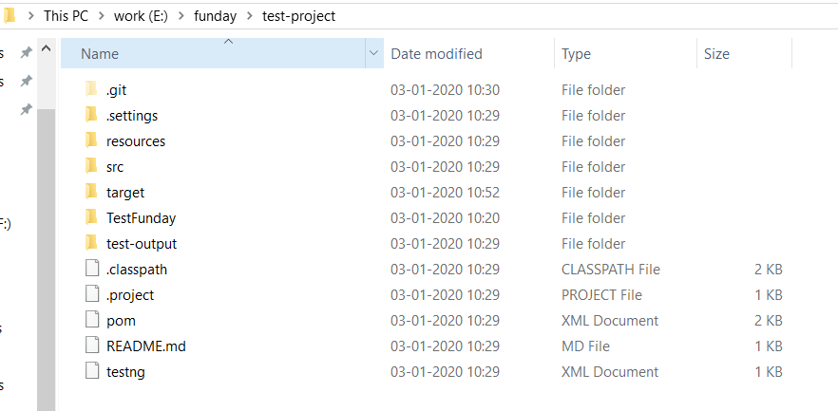

1. Open the terminal, navigate till the root directory path and run the command “mvn test” to execute the test suites:

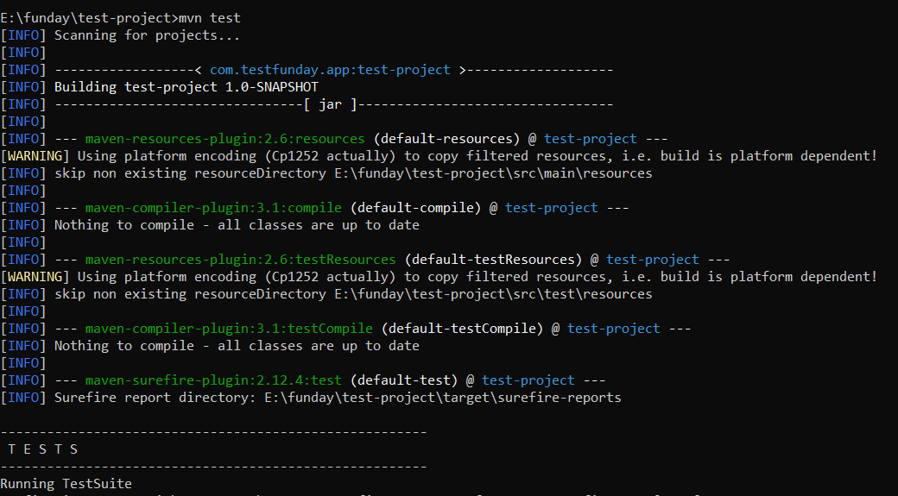

1. The test results can be found at following path in your local test machine:

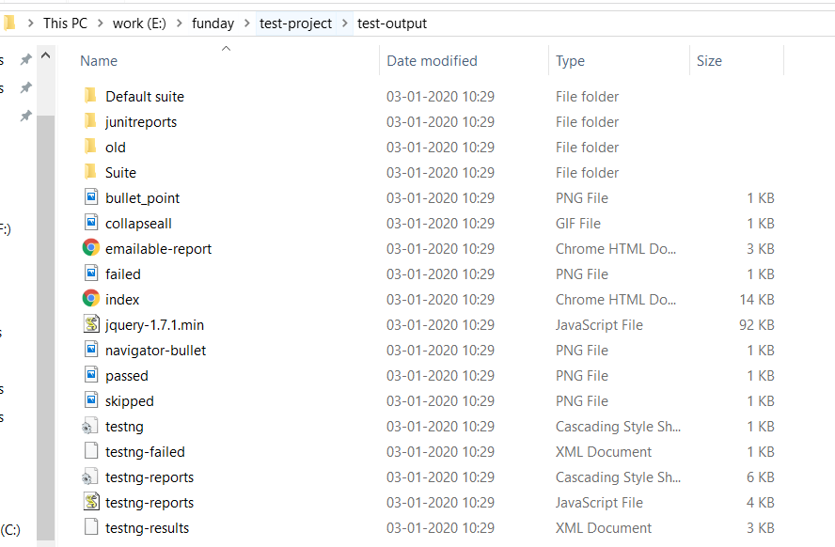

Open the ‘emailable-report’ HTML file or ‘index’ HTML file to see the test results.

Please feel free to contact me ([avbargaje@gmail.com](mailto:avbargaje@gmail.com)) in case of any difficulty to execute the project.